**LAB # 02**

**Array List and Vector in JAVA**

**Lab Tasks**

1. Write a program that initializes Vector with 10 integers in it. Display all the integers and sum of these integers.

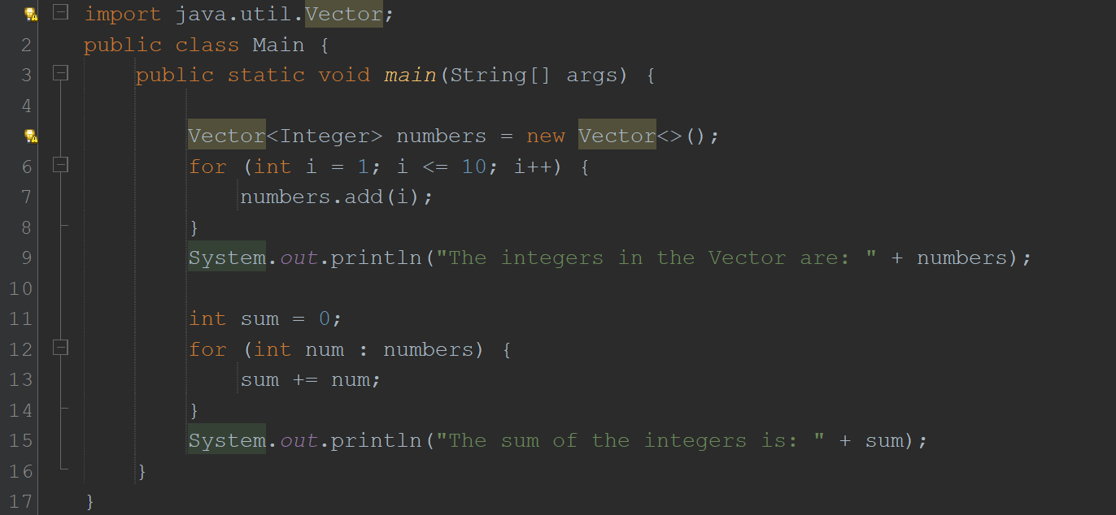

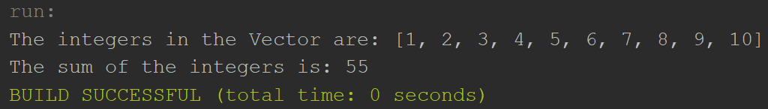

2. Create a ArrayList of string. Write a menu driven program which:

a. Displays all the elements

b. Displays the largest String

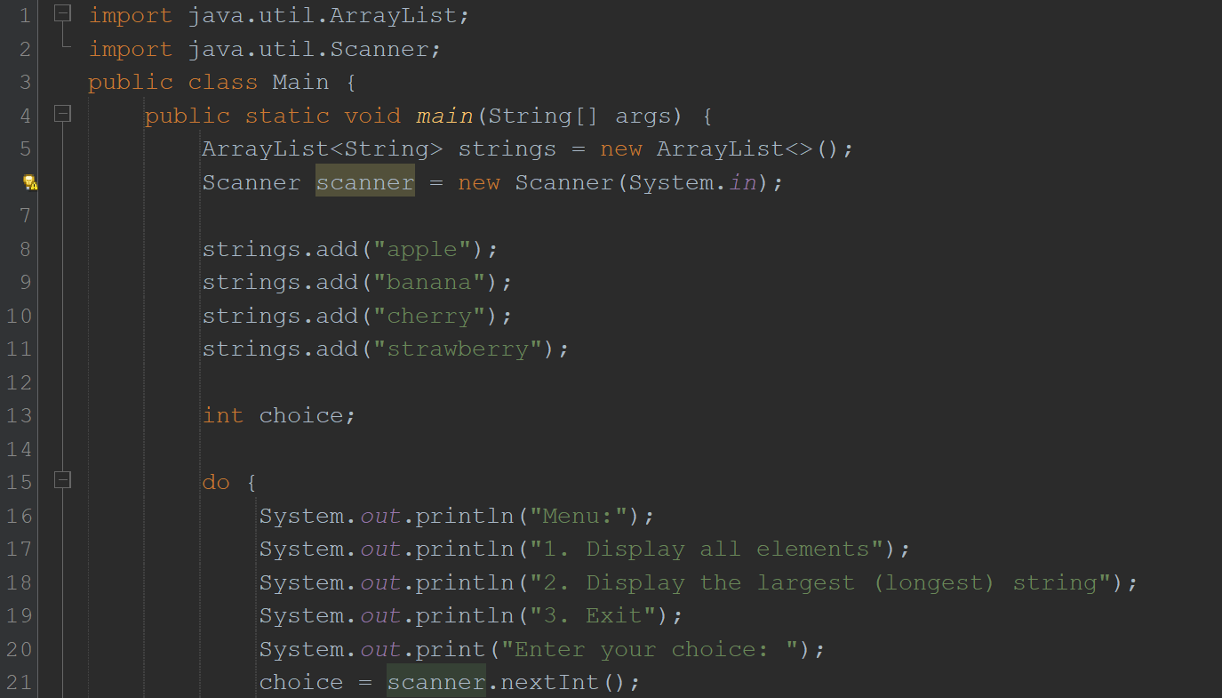

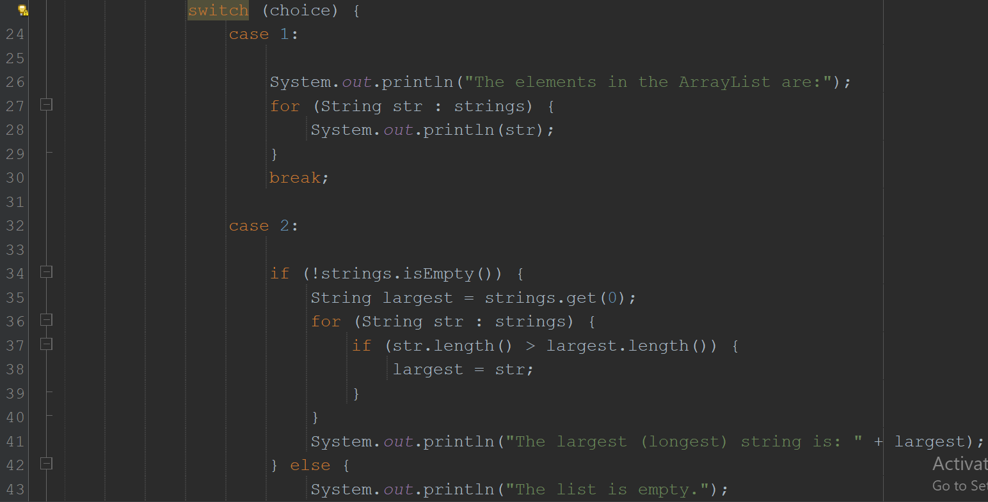

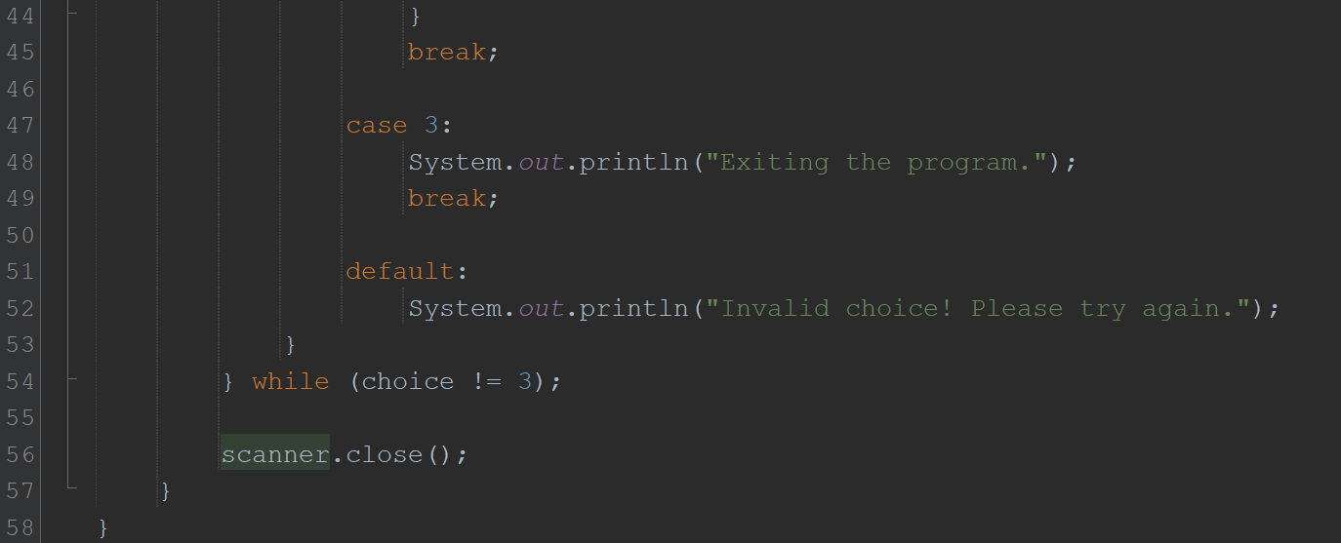

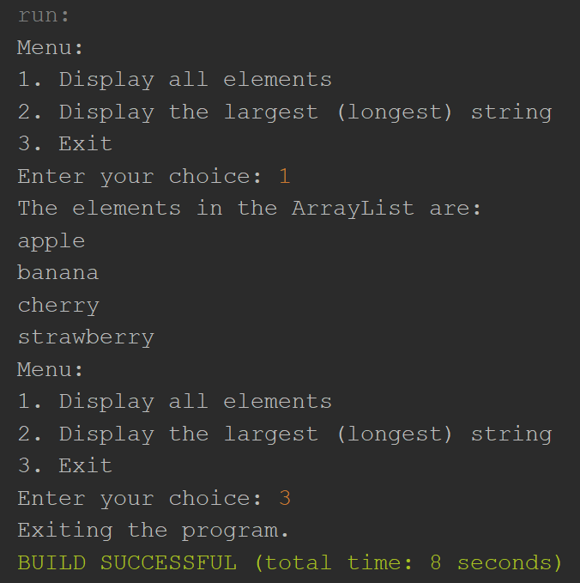

3. Create a Arraylist storing Employee details including Emp_id, Emp_Name, Emp_gender, Year_of_Joining (you can also add more attributes including these). Then sort the employees according to their joining year using Comparator and Comparable interfaces.

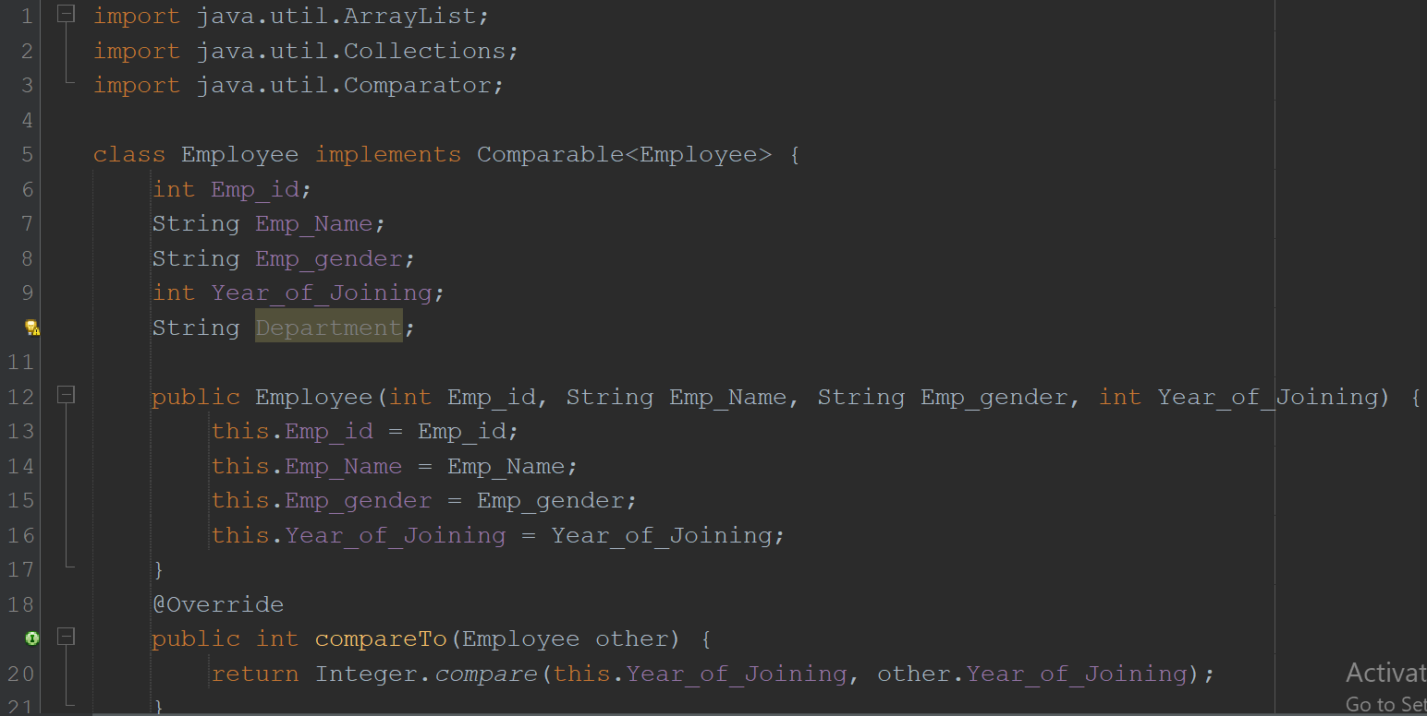

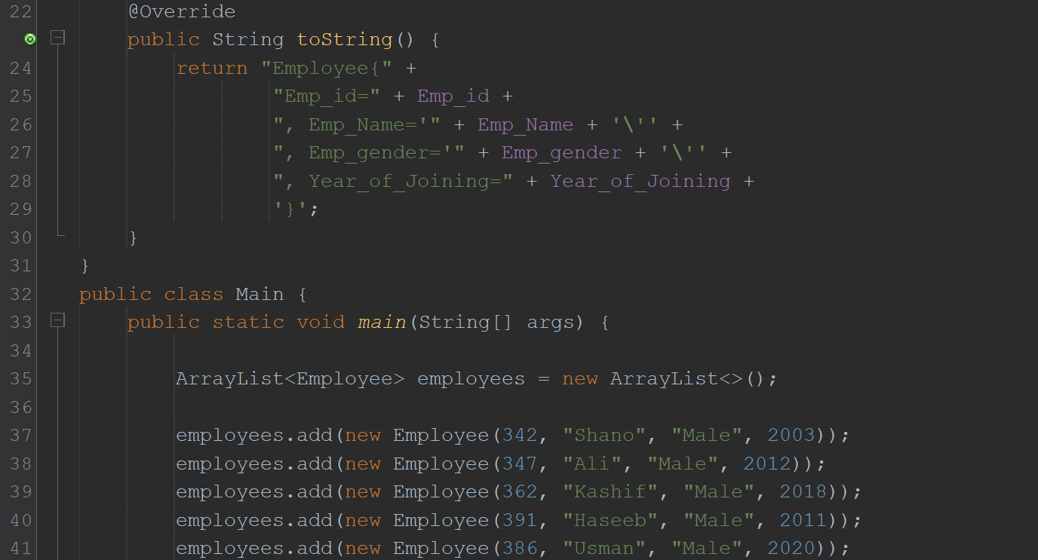

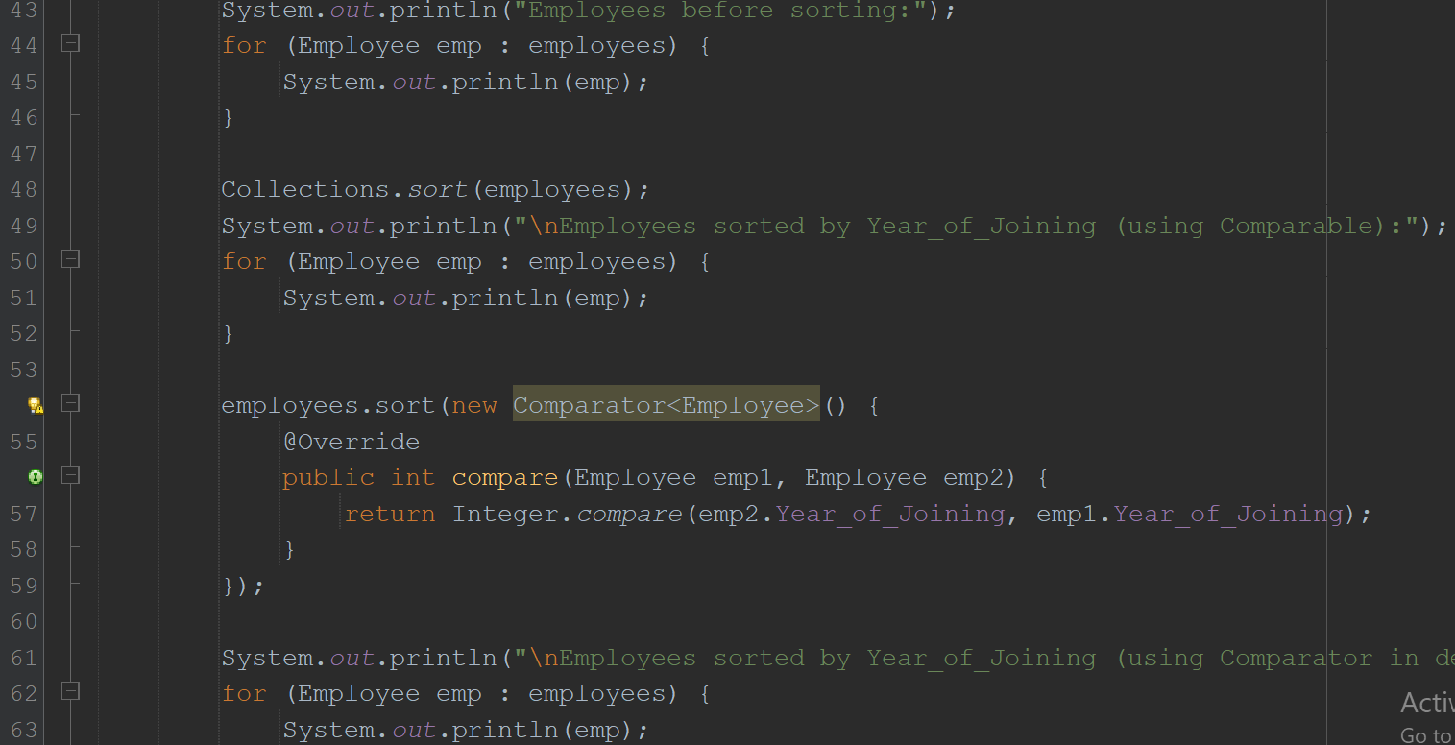

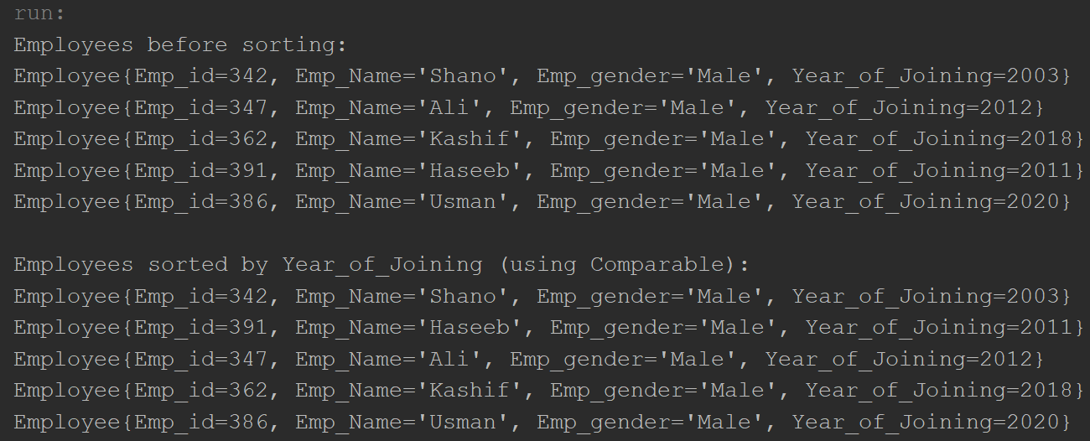

4. Write a program that initializes Vector with 10 integers in it.

• Display all the integers

• Sum of these integers.

• Find Maximum Element in Vector

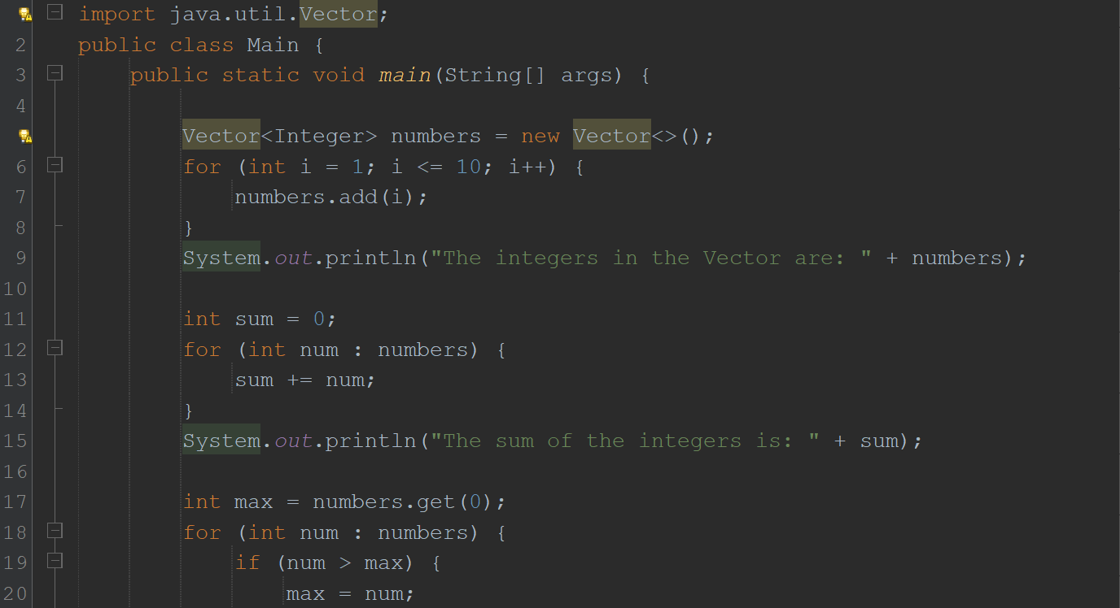

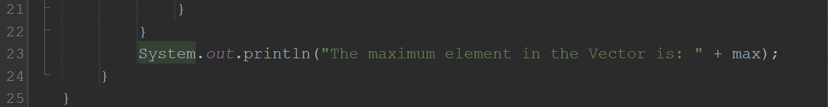

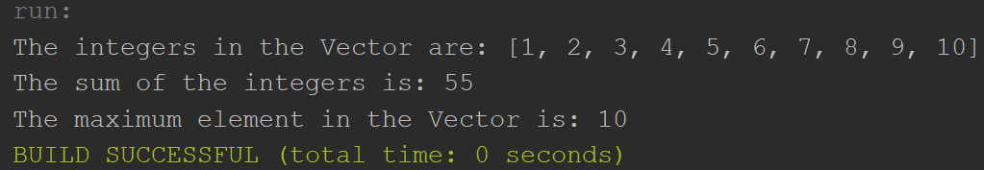

5. Find the k-th smallest element in a sorted ArrayList

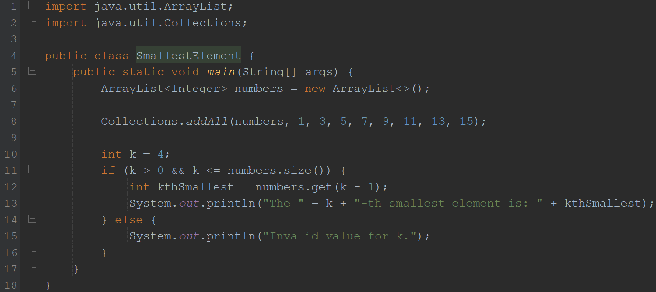

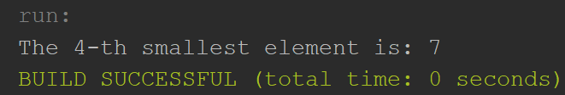

6. Write a program to merge two ArrayLists into one.

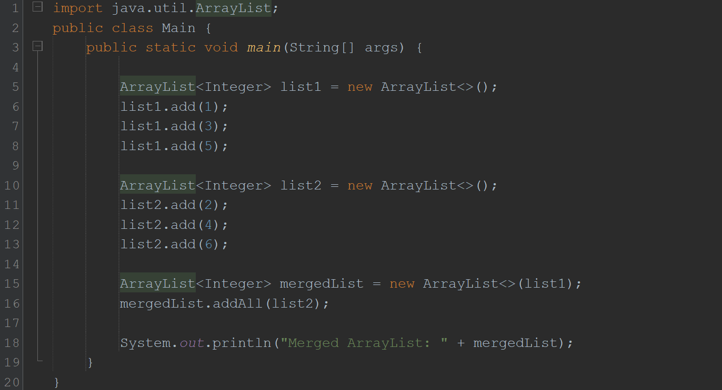

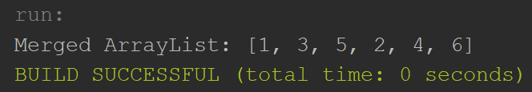

**Home Tasks**

1. Create a Vector storing integer objects as an input.

a. Sort the vector

b. Display largest number

c. Display smallest number

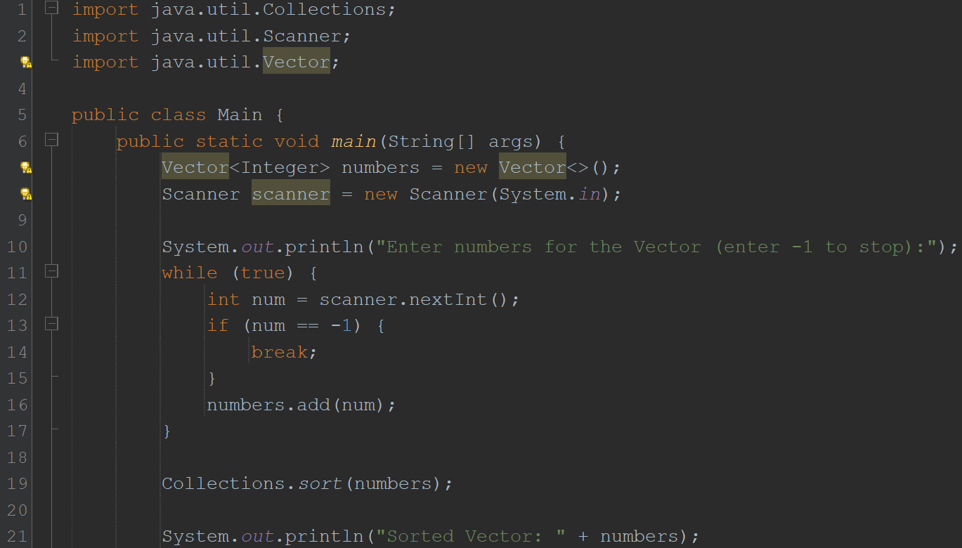

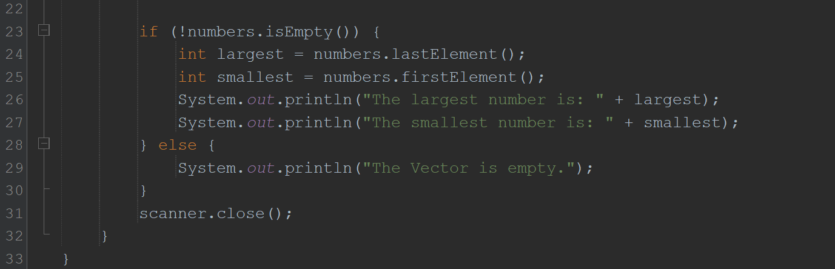

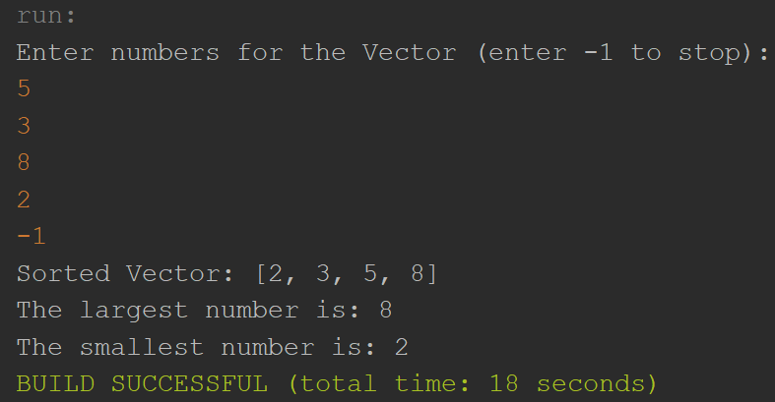

2. Write a java program which takes user input and gives hashcode value of those inputs using hashCode () method.

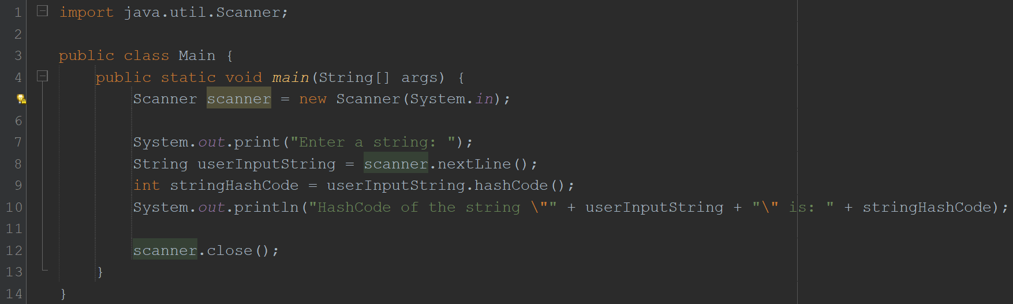

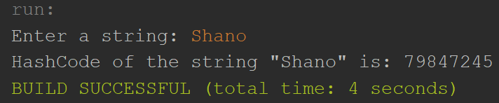

3. Scenario based

Create a java project, suppose you work for a company that needs to manage a list of employees. Each employee has a unique combination of a name and an ID. Your goal is to ensure that you can track employees effectively and avoid duplicate entries in your system.

Requirements

a. Employee Class: You need to create an Employee class that includes:

• name: The employee's name (String).

• id: The employee's unique identifier (int).

• Override the hashCode() and equals() methods to ensure that two employees are considered equal if they have the same name and id.

b. Employee Management: You will use a HashSet to store employee records. This will help you avoid duplicate entries.

c. Operations: Implement operations to:

• Add new employees to the record.

• Check if an employee already exists in the records.

• Display all employees.

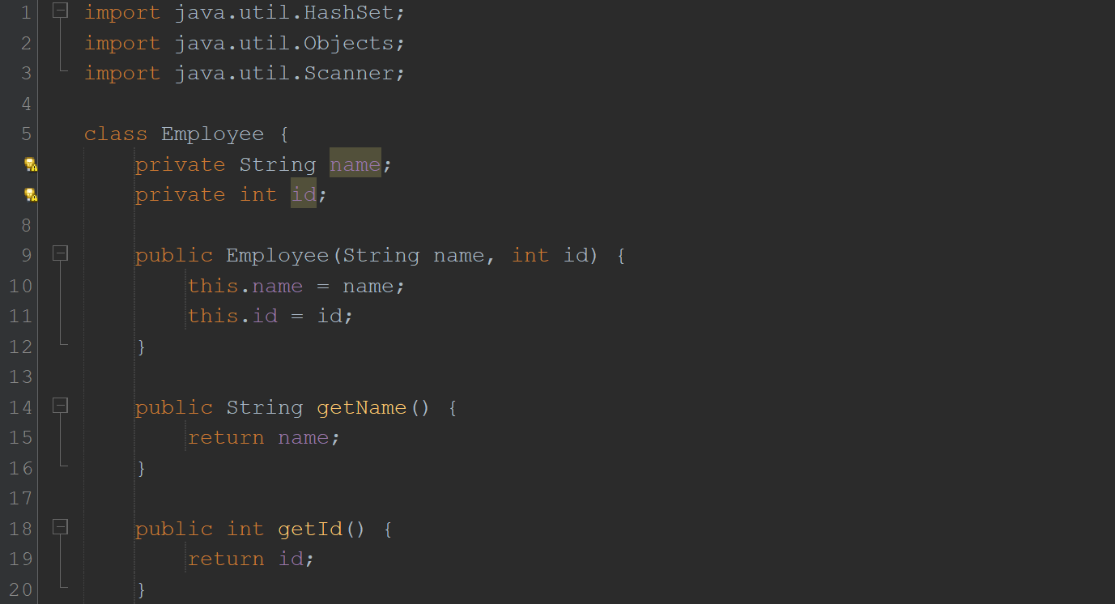

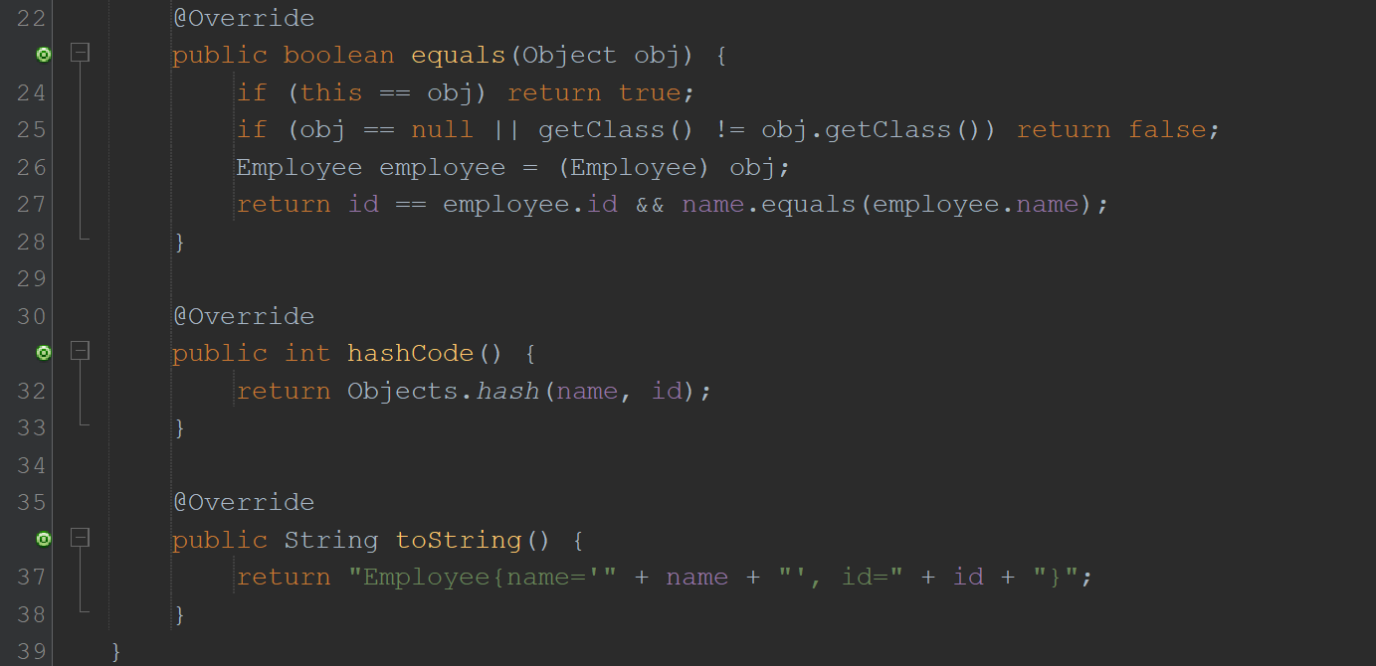

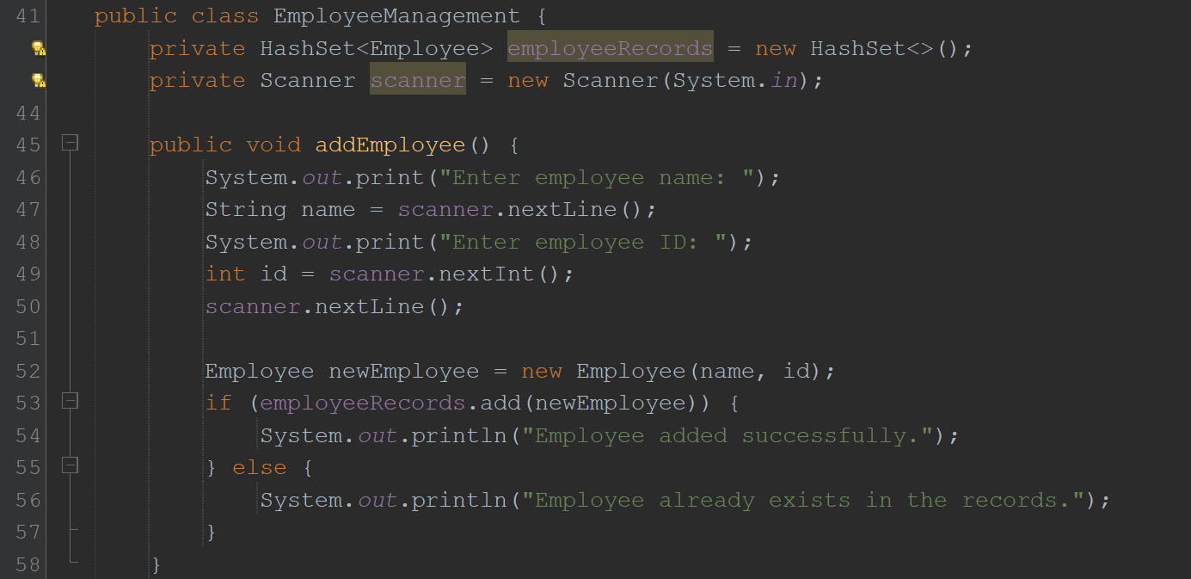

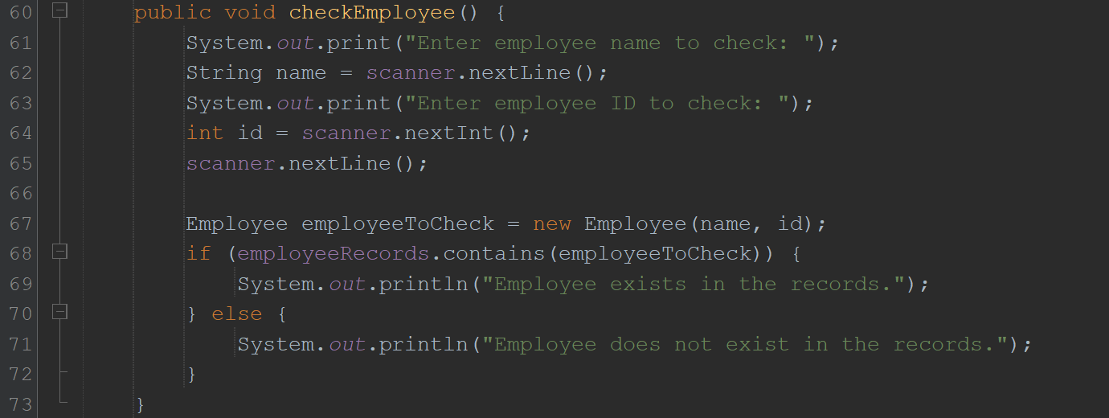

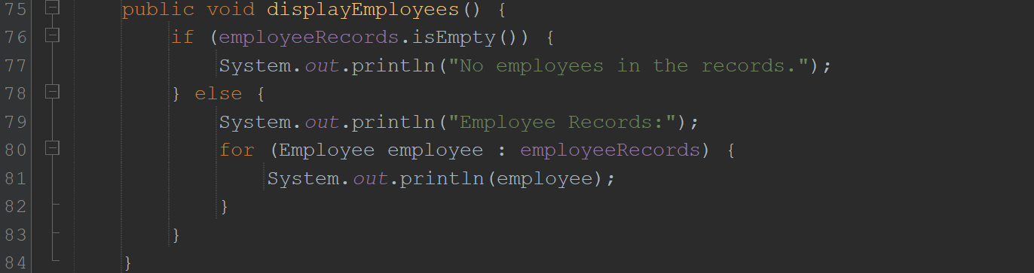

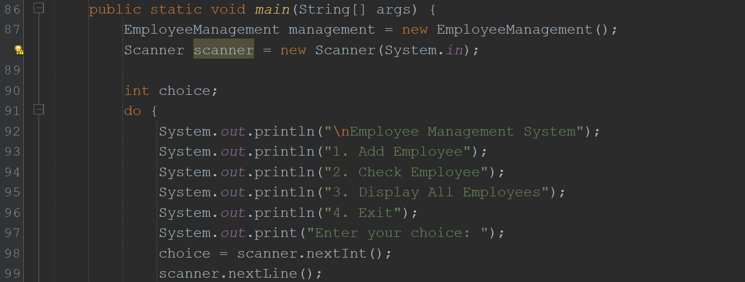

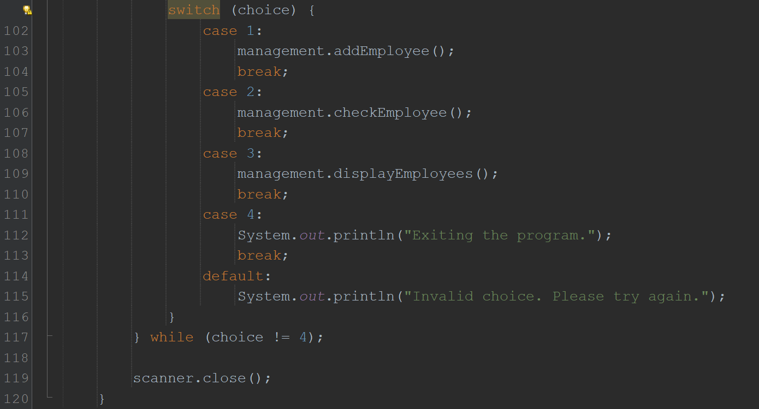

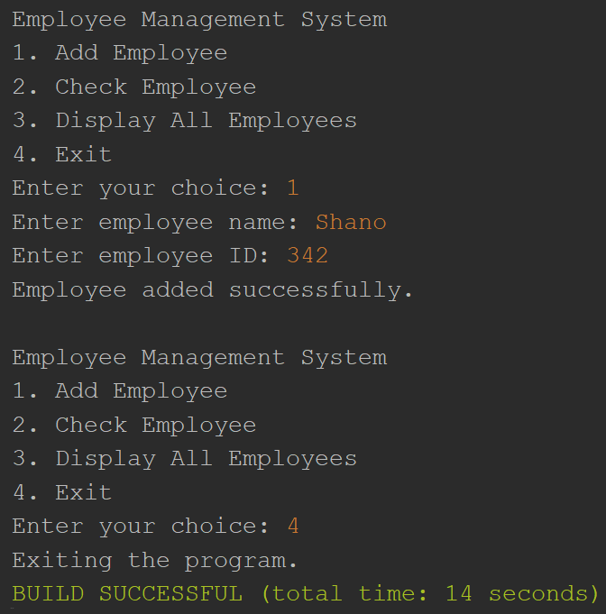

4. Create a Color class that has red, green, and blue values. Two colors are considered equal if their RGB values are the same

